Name

Anemometer Lab

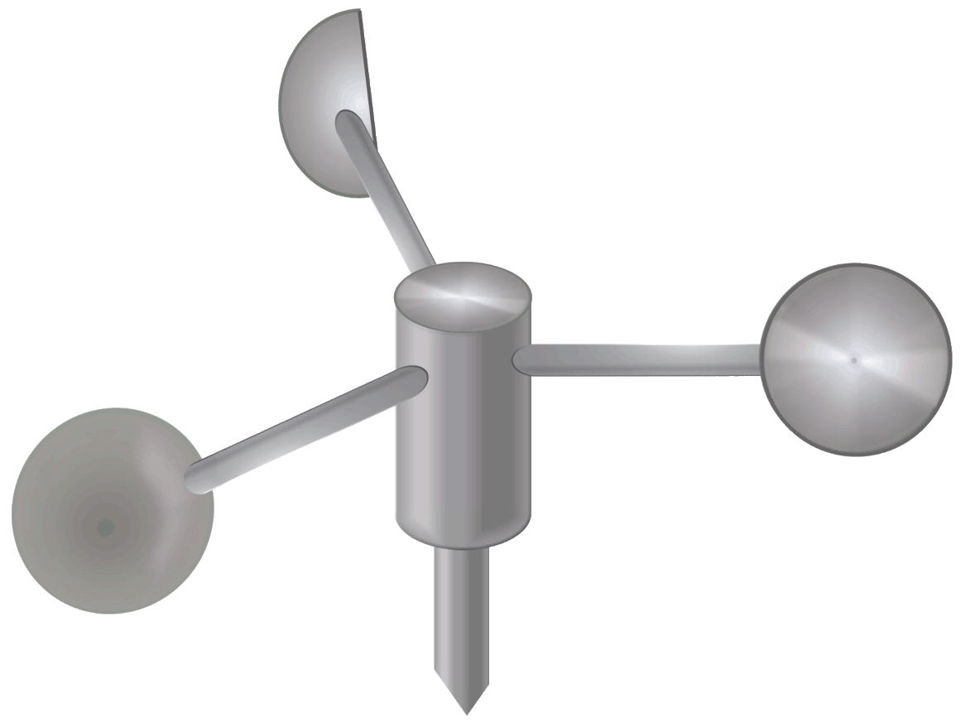There is a tool meteorologists use which we have not talked much about yet – the anemometer. Most people know this as just “the wind speed gauge.” It is a spinning device which measures the speed of the wind at any given time.

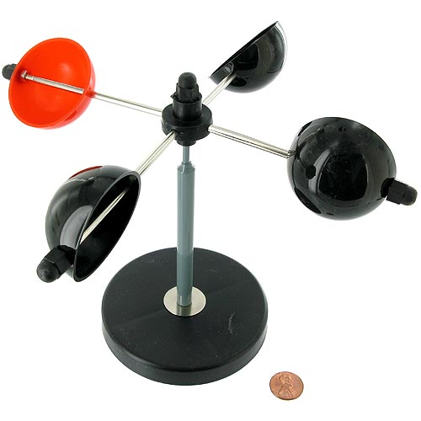An anemometer can be very easily built and used. All a person needs to build and use one is 4 cups, and pencil, a tack, a plate, a stapler, and some basic knowledge of geometry.

First, you must choose one of the cups to be the colored cup. Color the bottom of the cup with a marker brightly, so that you can easily see it.

Next, all cups should be stapled to the plate just like in the sample – it is important that they all face the correct direction, or your anemometer won’t work!

Next, you must tack the plate-cup device LOOSELY to the eraser of a pencil. It must balance, and be loose enough to spin freely.

Your anemometer is now ready to use!

In order to use your anemometer, you first need to calculate how far the cups travel in one spin. This is approximately the circumference of the plate. To get the circumference of the plate, use geometry!

Circumference = π(Diameter)

1. Measure the diameter with a ruler, and multiply by pi to get the circumference.
2. Next, you need a timer. The timer on your cell phone will work fine. Blowing into the cups as hard as you can, count how many times the colored cup goes around in 15 seconds. You may want to practice a bit first for best results.
3. Next, multiply your number by however many centimeters were in the circumference.
4. After that, multiple your number by 4 to see how many centimeters per minute the speed of your breath is.
5. Next multiply your number by 60 to see how many centimeters per hour your breath is.
6. Finally, divide by 1000 to see how many km/h your breath is!

Rotations in 15 seconds

Circumference of plate

4

60

1000

$$*$$

$$*$$

$$*$$

Plate circumference math:

Diameter

$$*$$

Circumference of plate

π

=

Breath speed math:

Once you have computed your data, add it to the table below. Then, gather the data of nine other classmates.

|  |  |  |  |  |  |  |  |  |  |  |
| --- | --- | --- | --- | --- | --- | --- | --- | --- | --- | --- |
| Individual Initials |  |  |  |  |  |  |  |  |  |  |
| Speed (km/hr) |  |  |  |  |  |  |  |  |  |  |

Finally, once you have this data collected, prepare a bar graph on the attached graph paper.

Closure Questions:

1. How fast is your breath?
2. According to the classroom data, what is the fastest breath speed in the class? The slowest?
3. Once more, what is the name of the tool we made, and what does it measure?
4. What are some problems with the version you created that prevent it from being very accurate?
5. Identify two professions, other than meteorologist, who might be interested in having data from this tool.

